Naveen Automation -

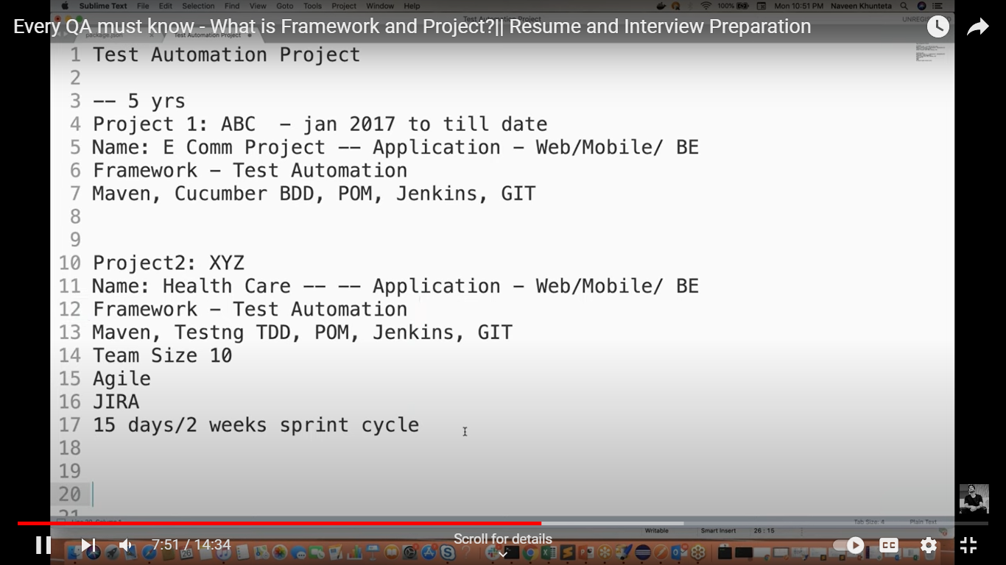

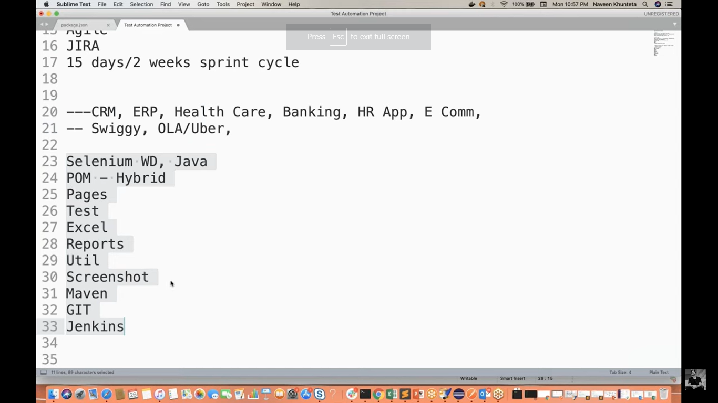

RD Automation Learning –

# Explain your contribution in Framework –

It was earlier created by team leads who were working on the project, and I have started working on the framework. Earlier in my team, Automation test coverage was 45% and with my test contribution it has been increase to 52%. I created these many (no. of) test scripts related to negative testing and now we are able to cover few of the corner cases because of which automation percentage has got increased.

Ex, created some utilities, batch files

